Phase 3
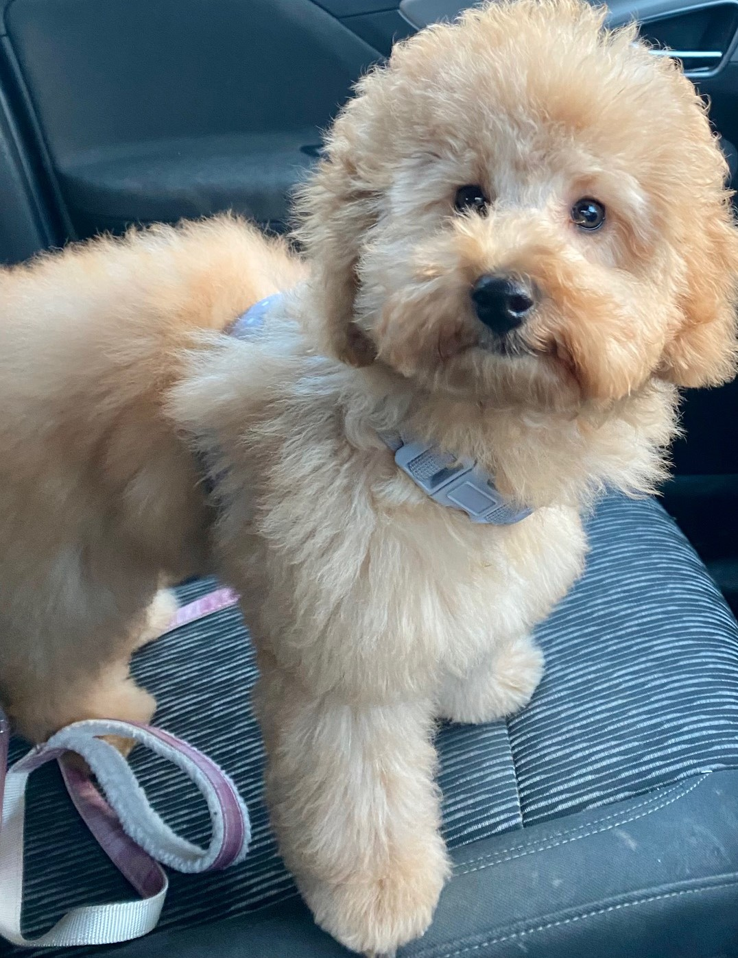

Miss Molly’s Adventures
Congratulations… Miss Molly has chosen to send her Miss Mini Molly toy home with you to have an adventure. Miss Molly asks that you take very good care of the toy Miss Molly, the adventure bag and the adventure book.
Miss Molly would love to read about where you took her (the toy) to, what you had to eat, the fun you had and how you took care of her. Make sure you remember what we have been learning about to keep all living things healthy, including Miss Molly and yourself. You can use one whole page to do some writing, draw pictures, do some maths and even stick a photograph in. Miss Molly loves having stories read to her too .
Have a great time.
Lots of love
Miss Molly 

