Information to help us to welcome Miss Molly our Therapy Dog to St. Paul’s
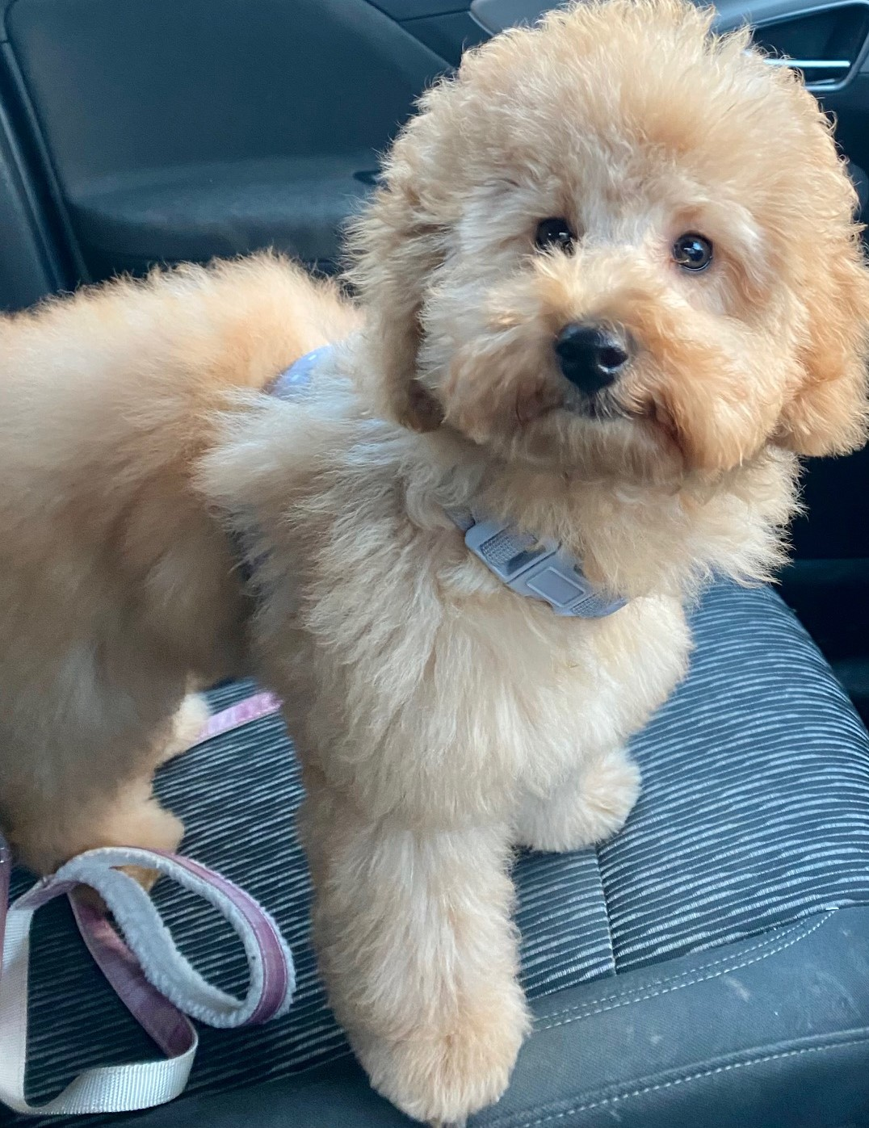

Understanding a dog’s body language
As our dogs can’t speak it’s important that we learn to understand their language! We can understand how our dogs feel by looking at their body language.
Young children should never interact with a dog without very close adult supervision. If you are aware of your dog’s body language, hopefully you can make sure they don’t become uncomfortable and can step in when needed. Never let a child take food or a toy from a dog, even if they know that dog well.
Helping our children to understand the subtle signs that your dog is feeling uncomfortable, afraid or anxious can be key to keeping them safe around dogs.
The signs a dog is uncomfortable include:
- Having their ears back
- Licking their lips
- Yawning
- Panting and pacing around
- Growling or baring their teeth
- Hiding
- Being submissive and cowering.
If a dog your child is interacting with is showing any of the above signs, it’s important to teach them to leave the dog alone. You can find out more about doggy body language in our free guide:
CANINE COMMUNICATION
Younger children can be more at risk with dogs because they will tend to be a little more excitable and can shout, scream, try to hug and kiss the dog and often don’t know when to stop and move away. Some dogs can find this attention frightening and may act defensively.
Dogs are great at reading changes in our body language, even subtle cues, however young children tend to be more unpredictable and erratic and can alarm dogs. With older children, if you teach your child to be calm and quiet around dogs this can help, but young children should always be a safe distance from dogs. As parents it’s important that you monitor these interactions and intervene as soon as your dog shows the first signs that they are uncomfortable.
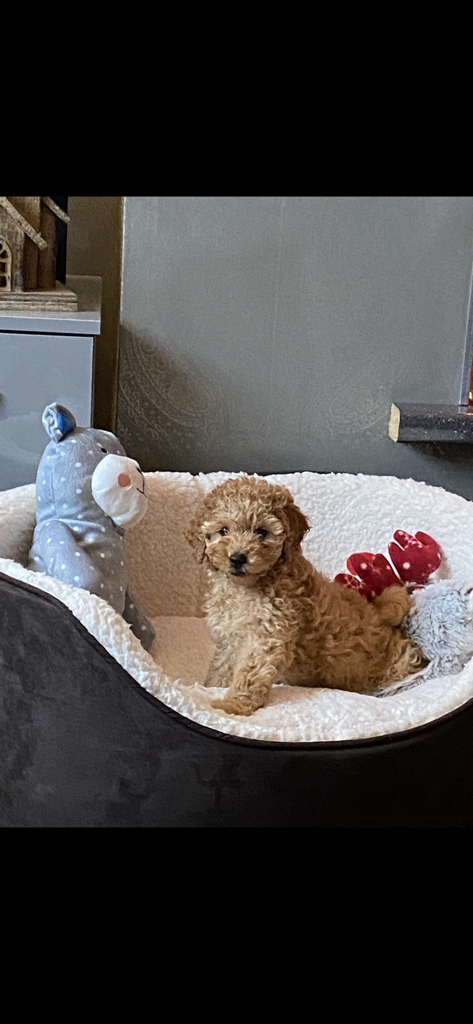

Ladder of communication
If a dog is feeling uncomfortable with a situation, they will start to display some body language signals to show that they are anxious and unsure. If these signals are ignored the situation can sadly escalate to the point that the dog may bite. This escalation of frustration is known as the ladder of canine communication. It is important to highlight that not every dog will show all of these behaviours or in this order.

LADDER OF COMMUNICATION

How to safely approach a dog
It’s a good idea to teach children how to safely approach a dog so they don’t scare them. Follow our simple steps:
- Always ask first. When teaching children to approach a dog, always make sure they ask (both you and the dog’s owner).
- Let them come to you and stay calm. Let the dog come to your child and sniff them, then pet them calmly and gently on back or chest. It’s a good idea to teach children not to touch dogs on their head or face or try to hug them.
- Give them space. Many people believe they should reach their hand out toward a dog, but this can be threatening for the dog and enters their personal space. Make sure children keep their arms by their side when greeting a dog.
- Make sure the dog is happy and comfortable. Once your child pets the dog, they should stop to ‘ask’ the dog if they want to continue being fussed. If the dog moves away or freezes, that’s a sign that the dog doesn’t want to be petted at the moment so it’s important your child can recognize this and move away from them. If the dog pushes their head or body into the child’s hand, seems happy and ‘wiggly’ and keen to continue getting pets then it’s okay to keep petting them.

What to do if a dog approaches a child
If a dog approaches a child in a way they find scary, you can teach them to ‘be a tree’ – stay still and keep their arms close to their body and not make any eye contact, then move slowly to walk away to find an adult.
This will hopefully show the dog that the child is not a threat and is also not someone fun to play with. Try to teach them to avoid running away. This will likely excite that dog and they may think that this is a game.
Safely introducing a dog or puppy to your family
Whenever you introduce a new dog to your home it is always important to take things slowly and never leave them unattended with your children.
If you’re looking to get a new puppy or dog, it’s worth doing your research before you commit:
- Be honest on the amount of time you can commit if you’ve got a family – is a dog the right pet for you?
- Look for dogs with needs that suit you.
- Pick a breed that is suitable to be around children as some breeds might not be suitable.
Always start by explaining to your family how they need to behave with a new dog and help your children understand your dog or puppy’s behaviour.
When you make your introductions they should be done in a calm, comfortable environment. Have your children sit quietly and bring the dog in to meet them. Make sure these experiences are positive for your dog or puppy and children.

Socialising your puppy with children
If you have a new puppy, it’s important to let them interact with children of all ages as part of their socialisation. Always reward your puppy for calm behaviour with a tasty treat or toy. You should always supervise your puppy with children and remove them from the situation if they’re getting afraid or boisterous.
These positive interactions will help your puppy feel less afraid of children and as an adult dog they should be relaxed and happy to be around children. If puppies miss this essential step in their training they can go on to be fearful of children when they’re adult dogs which can lead to conflict.

Our top tips for keeping children safe around dogs

- Never leave children unattended with a dog – even for a few minutes!
- Dogs may be protective of their toys and bowls or food, so children should always be more careful around these.
- Never let your children approach dogs they don’t know. Always ask the owner if it’s okay for their dog to be petted.
- Children should always treat dogs with respect. They should never be rough or boisterous as this may lead to them getting bitten.
- Train your dog not to jump up on people – it may be fun when they’re a puppy but that cute pup may grow into a much bigger dog that could seriously injure a small child.
- Let sleeping dogs lie – don’t let children disturb sick, injured or sleeping dogs as this may lead to your dog becoming upset.
- Childrens’ toys are not appropriate dog toys! Always be careful with the things your children may leave lying around. Be particularly careful with elastic bands and hair bobbles as children can be tempted to put these on dogs’ legs, ears and around their necks which can lead to serious injuries. Try to keep your child’s toys separate from your dog’s toys so that your dog learns the difference. Children’s toys can be fun to chew but easily destroyed into little pieces so always be careful that your dogs does not swallow anything they shouldn’t.
- Practice safe hygiene between your dog and children. Pick up any dog poo immediately so your children can’t touch it and always get your children to wash their hands after petting or playing with the dog.

