School Therapy Dog
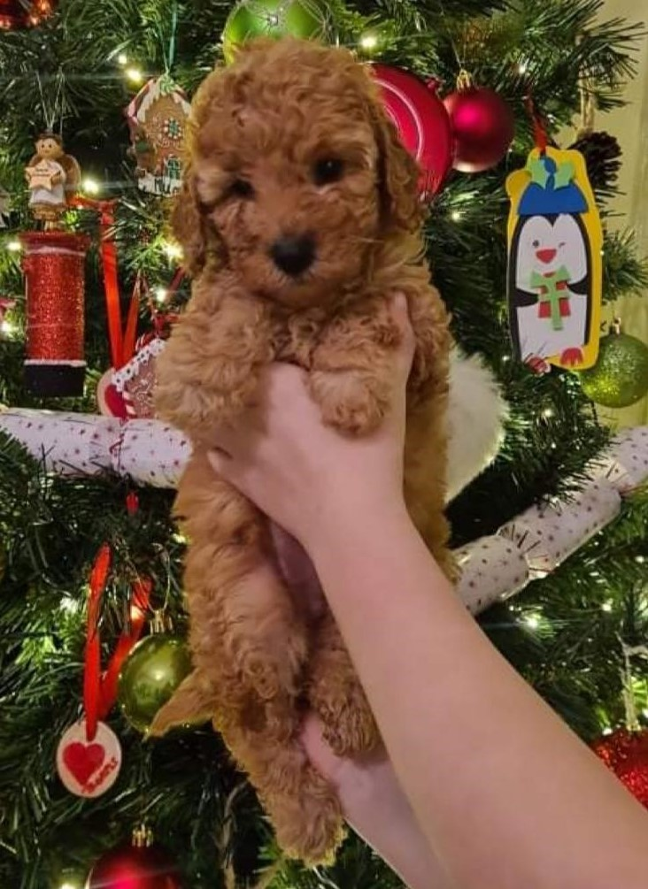

Hello, my name is Miss Molly and I am your school dog, I am also Mrs Rowley’s family pet. I am great at listening and love stories being read to me. I am only very young right now so need lots of help with my education too.
Read on to find out all about me from Mrs Rowley and how I can help everyone in the St. Paul’s C.E. Heathside Grove Family…
Miss Molly is a Cockapoo which is a mix of a Cocker Spaniel and a Poodle and they are renowned for being wonderful, intelligent dogs which are highly popular for families as they are a very loving, sociable breed. Miss Molly was born on 27th October 2021 and has three sisters and one brother.
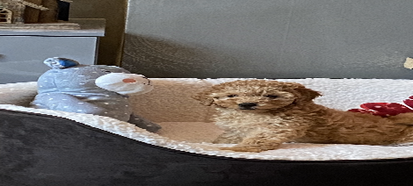

What are the benefits of Miss Molly?
- A calming effect on pupils, staff and parents
- Encouraging expression and participation in more withdrawn children
- Fostering a sense of responsibility
- Improved behaviour, attendance and concentration, reduced stress and improved self-esteem
- Motivating pupils to think and to learn, as most children have a high level of natural interest in, enthusiasm for, and enjoyment of animals.
- Encouraging respect and thereby improving pupil relationships with each other, parents and teachers.
- Helping work undertaken with the most vulnerable pupils, and educational improvements with lower achievers.
- Helping children build confidence in reading:-
https://www.theguardian.com/education/2011/feb/28/dogs-listen-to-children-reading
- Cognitive – companionship with a dog stimulates memory, problem-solving and game-playing
- Physical – interaction with a furry friend reduces blood pressure, provides tactile stimulation, assists with pain management, gives motivation to move, walk and stimulates the senses.
- Emotional – Miss Molly improves self-esteem, acceptance from others and lifts mood, often provoking laughter and fun. She can also teach compassion and respect for other living things as well as relieving anxiety.
- Social – Miss Molly provides a positive mutual topic for discussion, encourages responsibility, wellbeing and focused interaction with others.
Guidelines to interaction with Miss Molly
There will always be a responsible adult in charge of Miss Molly during interactions with children. Children and adults are required to adhere to the following;
- Always approach Miss Molly calmly and slowly
- Never run up to Miss Molly
- Offer the back of your hand for Miss Molly to sniff when meeting her
- All interactions must remain calm with the authorised adult in control at all times
- Pupils must wash their hands after they have been stroking Miss Molly

Cockapoo’s are hypoallergenic (meaning they don’t moult) and are generally well mannered and fun-loving dogs. Miss Molly has regular check-ups at the vet and has updated vaccinations, flea and worming treatment.

Frequently Asked Questions
What will Miss Molly do on a day to day basis?
Miss Molly will be based in Mrs Rowley’s office. She may visit different classes or help with particular projects, such as learning about caring for animals. Miss Molly will always be kept on a lead, unless contained in the Headteacher’s office.
How do I know that my child will be safe around Miss Molly?
A risk assessment will be in place and will be available on the school website. The school has insurance to cover having a dog on the school site. Pupils will only have contact with Miss Molly when supervised by an adult. When moving around the school, Miss Molly, will always be on the lead.
Will my child pick up infections from the dog?
Miss Molly is fully vaccinated, treated regularly for worms and fleas and will be kept away from the school if she is ill. Pupils will be required to wash their hands after handling the dog.
What if my child is allergic to dogs or afraid of them?
Miss Molly is a hypoallergenic dog. Parents can request that their child has no contact or restricted access to Miss Molly in these situations. Please speak to Mrs Rowley, Mrs Hick or Mrs Whitehead to discuss any concerns.

