Project Book

This term, our Science topic is all about Animals Including Humans
We will be looking at:

- What animals including humans need in order to survive.
- Carnivores, herbivores and omnivores.
- Different species of animals.

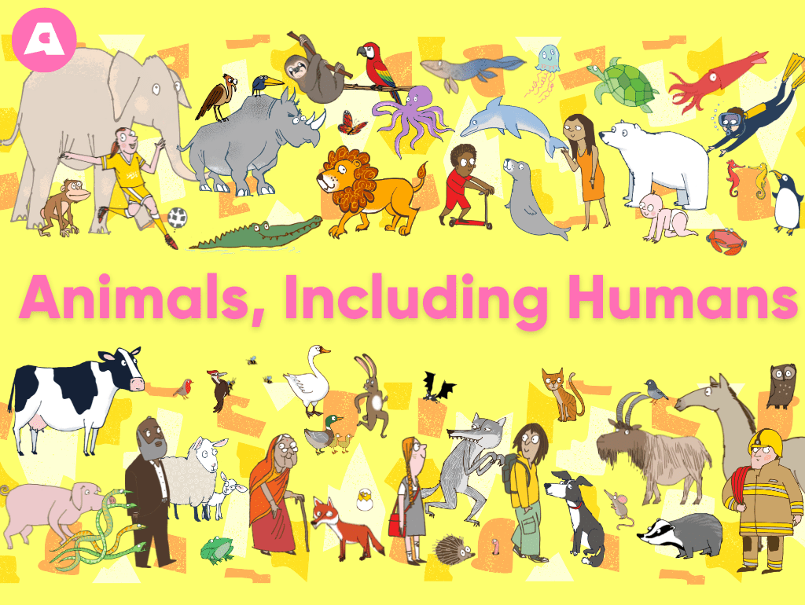

You could:

- Group animals including humans based on their characteristics.
- Build an animal’s habitat of your choice!
- Create an animal mask and a simple fact poster about a favourite animal.

Or D&T topic is all about planning, designing and making a smoothie!
We will be looking at:

- Identifying different types of fruit and vegetables.
- Holding kitchen utensils safely.
- Practicing different methods to prepare fruit and vegetables.
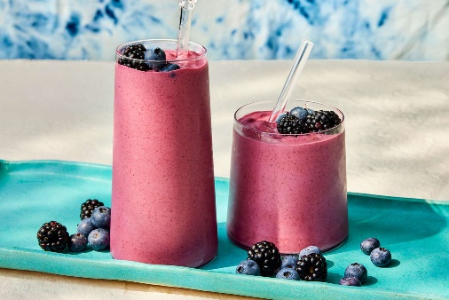

You could:

- Design your own healthy smoothie at home (don’t forget to take pictures)!
- Draw your own smoothie creation and recipe!

