The Human Body and Senses.

This half term we will be learning all about the parts of the human body and the five senses in Science and the different countries and capitals of the UK in Geography.
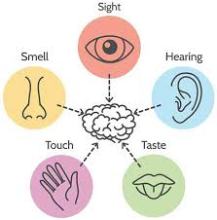
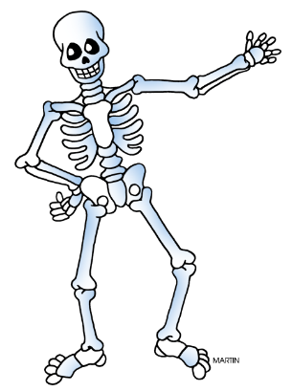
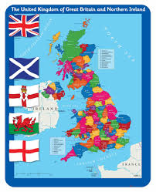

Here are some ideas for the activities you could do:
- Label the parts of the human body.
- Carry out a science experiment to test your senses.
- Research the UK
- Draw or make a model of a map of the UK.
- Research the capital cities.
Remember, this is your project book and you can choose to do as many activities as you like or think or your own.

