The Great Outdoors

This half term we will be learning all about where our school is located. We will also be finding out about different types of trees and plants and their parts.

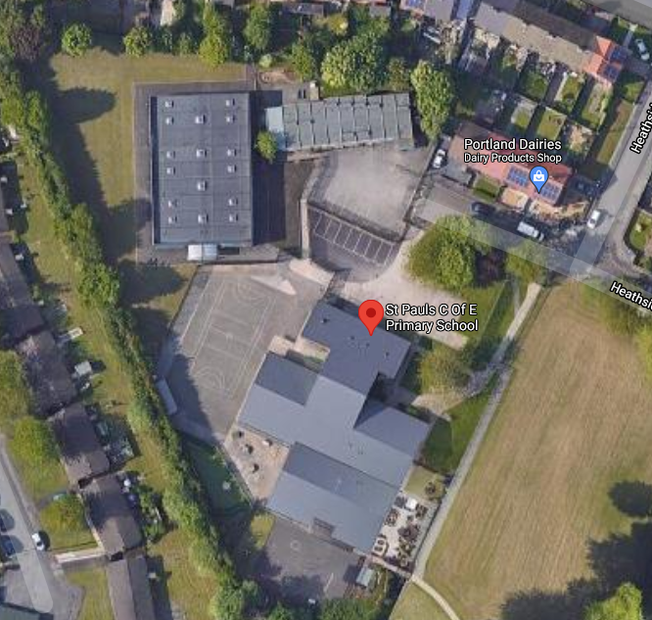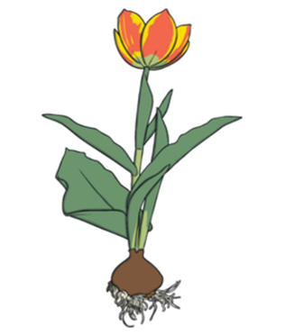

Here are some ideas for activities that you could do:

- Draw a picture of our school.
- Write our school address and postcode.
- Draw a map of our school grounds.
- Draw some pictures of things in the local area and label them.
- Draw pictures of plants, flowers and trees that you have seen in the local area.
- Draw a flowering plant and label its parts.
- Draw a tree and label its parts.
- Go on a walk to Blackleach or Parr Fold Park and take some photographs of plants and trees and write about what you find.
Project books need to be handed in by 16.10.23

