Literacy Progression of skills, Knowledge, Questions and Vocabulary.
Nursery
 |  | Transcription | Composition | Vocabulary | Love of reading
Autumn 1 | 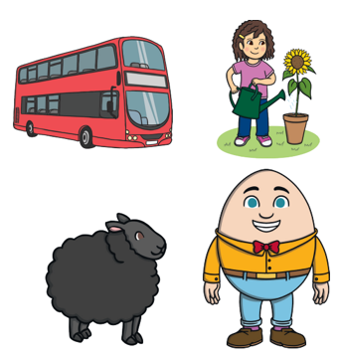 | • Gross motor activities:(climbing swinging messy play parachute games) | • Know many rhymes  • Sing a large repertoire of songs.  •Remember and sing entire songs  Sing the pitch of a tone sung by another person (‘pitch match’).  • Sing the melodic shape (moving melody, such as up and down and down and up) of familiar songs.  • Create their own songs, or improvise a song around one they know.  (All start in A1 but continue throughout the year) |  | Understand the five key concepts about print:  • print has meaning  • print can have different purposes • we read English text from left to right and from top to bottom  • the names of the different parts of a book  • page sequencing
Autumn 2 | 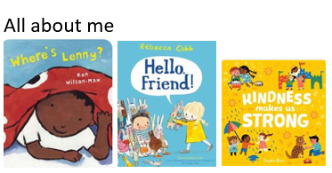 | • Develop fine motor coordination through using tools and equipment to cut (scissors, sewing, painting)  •Write some or all of my name | • be able to talk about familiar books .  •Use talk to organise themselves and their play: “Let’s go on a bus… you sit there… I’ll be the driver.”  •Can start a conversation with an adult or a friend and continue it for many turns. | •Learn new vocabulary.  •Explain unfamiliar words and concepts through stories and other activities | Understand the five key concepts about print:  • print has meaning  • print can have different purposes • we read English text from left to right and from top to bottom  • the names of the different parts of a book  • page sequencing
Spring 1 | 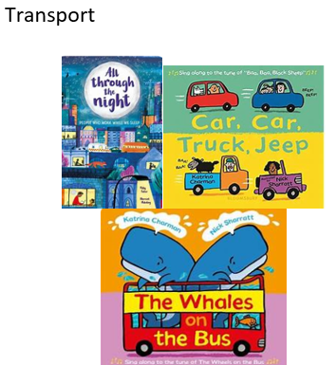 | •Pick up small objects and engage in activities that develop fine motor skills.  •Write some or all of my name  •Recognise words with some initial sounds  •Spot rhymes | • be able to talk about familiar books, encourage children to talk about what is happening and give their own ideas.  • Engage in conversations about stories, learning new vocabulary.  •Can start a conversation with an adult or a friend and continue it for many turns. | •Learn new vocabulary.  •Explain unfamiliar words and concepts through stories and other activities | Understand the five key concepts about print:  • print has meaning  • print can have different purposes • we read English text from left to right and from top to bottom  • the names of the different parts of a book  • page sequencing
Spring 2 | 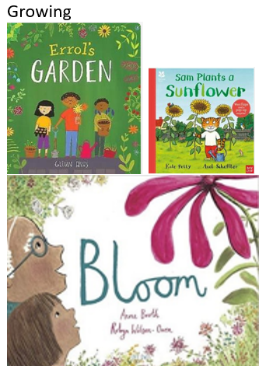 | •Write some or all of my name  •Recognise words with some initial sounds  •Spot rhymes  •Count and clap syllables in words.  •use a comfortable grip when holding pens and pencils (tripod grip) | • be able to talk about familiar books  • Engage in extended conversations about stories, learning new vocabulary.  •Can start a conversation with an adult or a friend and continue it for many turns. | •Learn new vocabulary.  •Explain unfamiliar words and concepts through stories and other activities | Understand the five key concepts about print:  • print has meaning  • print can have different purposes • we read English text from left to right and from top to bottom  • the names of the different parts of a book  • page sequencing
Summer 1 |  | •Write some or all of my name  Recognise words with some initial sounds  •Spot and suggest rhymes  •Count and clap syllables in words. | • be able to talk about familiar books  • Engage in extended conversations about stories, learning new vocabulary.  •Can start a conversation with an adult or a friend and continue it for many turns. | •Learn new vocabulary.  •Explain unfamiliar words and concepts through stories and other activities | Understand the five key concepts about print:  • print has meaning  • print can have different purposes • we read English text from left to right and from top to bottom  • the names of the different parts of a book  • page sequencing
Summer 2 |  | •Write some or all of my name  • Write some letters accurately. | • be able to tell a long story.  • Begin to develop complex stories using small world equipment, like animal sets, dolls and dolls houses etc.  •Be able to express a point of view and to debate when they disagree with an adult or a friend, using words as well as actions.  •Can start a conversation with an adult or a friend and continue it for many turns.  •use longer sentences of four to six words.  •Answer simple why questions.  shared book reading followed by conversations with children.  •use sentences joined up with words like because or and | •Use a wider range of vocabulary.  Understand why questions, like: why do you think the caterpillar got so fat?  •Develop their communication, but may continue to have problems with irregular tenses and plurals, such as ‘runned’ for ran ‘swimmed’ for swam. | Understand the five key concepts about print:  • print has meaning  • print can have different purposes • we read English text from left to right and from top to bottom  • the names of the different parts of a book  • page sequencing
Continuous provision throughout the year |  | • Use large-muscle movements to wave flags and streamers, paint and make marks.  • Use one-handed tools and equipment, for example, making snips in paper with scissors.  • Use a comfortable grip with good control when holding pens and pencils.  • Shows a preference for a dominant hand.  •Use some of their print and letter knowledge in their early writing. For example: writing a pretend shopping list that starts at the top of the page; write ‘m’ for mummy. | •Take part in simple pretend play, using an object to represent something else even though they are not similar.  •Expand children’s phrases | •Provide children with a rich language environment  •Offer children lots of interesting things to investigate and ask questions.

Reception
 |  | Transcription | Composition | Vocabulary | Love of reading
Autumn 1 | 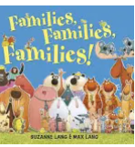  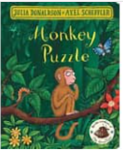 | Activates to further develop and refine fine motor skills ( threading; woodwork pouring; stiring; dressing; and undressing; small world toys; planting; junk modelling; construction kits and malleable material). | • Describe events in some detail.  •Engage in a story  •Retell the story, once they have developed a deep familiarity with the text; some as exact repetition.  •Connect one idea or action to another using a range of connectives  •Learn rhymes poems and songs  •Sing in a group or on their own, increasingly matching the pitch and following the melody.  •Listen to and talk about selected non-fiction to develop a deep familiarity with new knowledge and vocabulary. | • Learn new vocabulary.  • Use new vocabulary throughout the day. | Understand the five key concepts about print:  • print has meaning  • print can have different purposes • we read English text from left to right and from top to bottom  • the names of the different parts of a book  • page sequencing
Autumn 2 | 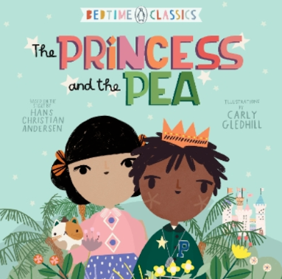   | • Use their core muscle strength to achieve a good posture when sitting at a table or sitting on the floor.  •Form lower case letters correctly. ( when forming letter the starting point and direction are more important at this stage than the size or position on a line).  •Provide areas for sitting at a table (with chairs and footrests at the correct height)  •Develop the foundations for a fast and accurate handwriting style encourage children to draw.  Guide what to draw, write or copy.  •Continuously check children are holding pencils correctly with regular practice to encourage an effective handwriting style. | •Listen to and talk about stories to build familiarity and understanding.  •Retell the story, once they have developed a deep familiarity with the text; some as exact repetition.  •Learn rhymes poems and songs |  | •Read individual letters by saying the sounds for them  Blend sounds into words, so that they can read short words made up of known letter– sound correspondences  •Re-read these books to build up their confidence in word reading, their fluency and their understanding and enjoyment
Spring 1 | 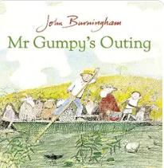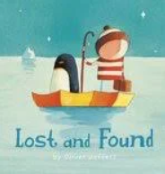  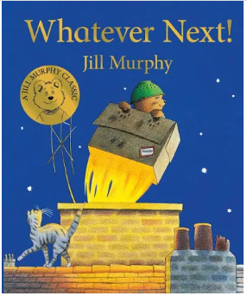 | • Spell the initial sounds by identifying the sounds and then writing the sound with the letter/s.  •Spell words by identifying the sounds and then writing the sound with the letter/s.  •Continuously check children are holding pencils correctly with regular practice to encourage an effective handwriting style.  •Dictate phrases to ensure they contain only the taught sound-letter correspondences. | •Listen to and talk about stories to build familiarity and understanding.  •Retell the story, once they have developed a deep familiarity with the text; some as exact repetition.  •Learn rhymes poems and songs  •Sing in a group or on their own, increasingly matching the pitch and following the melody.  •Listen to and talk about selected non-fiction to develop a deep familiarity with new knowledge and vocabulary. |  | •Read individual letters by saying the sounds for them  Blend sounds into words, so that they can read short words made up of known letter– sound correspondences  •Read a few common exception words matched to the school’s phonic programme  •Re-read these books to build up their confidence in word reading, their fluency and their understanding and enjoyment
Spring 2 | 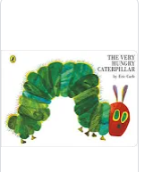  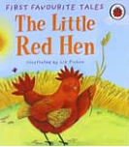 | •Dictate sentences to ensure they contain only the taught sound-letter correspondences.  •Touch each word as they say the sound.  Identify the sound that is tricky to spell in the tricky word.  •Write recognisable letter most of which are correctly formed.  •Continuously check children are holding pencils correctly with regular practice to encourage an effective handwriting style. | •Listen to and talk about stories to build familiarity and understanding.  •Retell the story, once they have developed a deep familiarity with the text; some as exact repetition.  •Learn rhymes poems and songs  •Listen to and talk about selected non-fiction to develop a deep familiarity with new knowledge and vocabulary.  •Help children memorise the sentence before writing by repeatedly saying it aloud through talk for writing.  •Only ask children to write phrases when they have sufficient knowledge of letter-sound correspondences.  •Help children to memorise the phrases before writing by repeatedly saying it aloud through talk for writing. |  | •Read simple phrases and sentences made up of words with known letter–sound correspondences and, where necessary, a few exception words.  •Re-read these books to build up their confidence in word reading, their fluency and their understanding and enjoyment
Summer 1 | 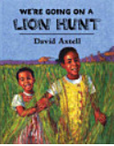   | •Write short sentences with words with known letter-sound correspondences using a capital letter and a full stop. | •Listen to and talk about stories to build familiarity and understanding.  •Retell the story, once they have developed a deep familiarity with the text; some as exact repetition and some in their own words  •Re-read what they written to check that it makes sense  • Write simple phrases and sentences that can be read by others.  • Invent, adapt and recount narratives and stories with peers and teachers.  •Learn rhymes poems and songs  •Sing in a group or on their own, increasingly matching the pitch and following the melody.  •Only ask children to write sentences when they have sufficient knowledge of letter-sound correspondences.  •Help children to memorise the sentences before writing by repeatedly saying it aloud through talk for writing. |  | •read aloud simple sentences and books that are consistent with their phonic knowledge, including some common exception words.  •Re-read these books to build up their confidence in word reading, their fluency and their understanding and enjoyment
Summer 2 | 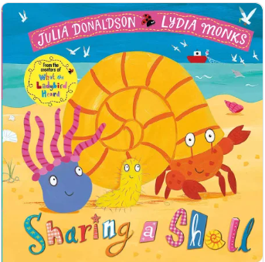   | • Hold a pencil effectively in preparation for fluent writing – using the tripod grip in almost all cases.  • Write recognisable letters, most of which are correctly formed  •Form lower case and capital letter correctly.  • Write recognisable letters, most of which are correctly formed.  • Spell words by identifying sounds in them and representing the sounds with a letter or letters. | •Participate in small group, class and one-to one discussion, offering their own ideas, using recently introduced vocabulary.  • Offer explanations for why things might happen, making use of recently introduced vocabulary from stories, non-fiction, rhymes and poems when appropriate.  • Express their ideas and feelings about their experiences using full sentences, including use of past, present and future tenses and making use of conjunctions, with modelling and support from their teacher.  •Learn rhymes poems and songs  •Demonstrate understanding of what has been read to them by retelling stories and narratives using their own words and recently introduced vocabulary. | • Offer explanations for why things might happen, making use of recently introduced vocabulary from stories, non-fiction, rhymes and poems when appropriate.  • Express their ideas and feelings about their experiences using full sentences, including use of past, present and future tenses and making use of conjunctions, with modelling and support from their teacher. | •say a sound for each letter in the alphabet and at least 10 digraphs;  read words consistent with their phonic knowledge by sound-blending;  •read aloud simple sentences and books that are consistent with their phonic knowledge, including some common exception words.
Continuous provision throughout the year |  | • Develop their small motor skills so that they can use a range of tools competently, safely and confidently. Suggested tools: pencils for drawing and writing, paintbrushes, scissors, knives, forks and spoons.  • Use their core muscle strength to achieve a good posture when sitting at a table or sitting on the floor.  • Develop the foundations of a handwriting style that is fast, accurate and efficient. | • Articulate their ideas and thoughts in well-formed sentences.  •Listen to and talk about selected non-fiction to develop a deep familiarity with new knowledge and vocabulary.  • Use talk to help work out problems and organise thinking and activities. Explain how things work and why they might happen.  •Develop storylines in their pretend play.  •Develop social phrases  •Engage in no- fiction books  •Make use of props and materials when role playing characters in narratives and stories.  •Invent, adapt and recount narratives and stories with their peers and their teacher.  •Perform songs, rhymes, poems and stories with others, and (when appropriate) try to move in time to music.  •recast what children have said  • When children have difficulties with the correct pronunciation, reply naturally to what they say, Pronounce the word correctly so they hear the correct model.  • Articulate their ideas and thoughts in well-formed sentences.  •use complete sentences in everyday talk  •Help children build sentences using new vocabulary by rephrasing what they say and structuring their responses using sentence starters.  •Story time once a day and display books in the environment. | •Use new vocabulary in different contexts  •develop a deep familiarity with new knowledge and vocabulary.  •Use and understand recently introduced vocabulary during discussions about stories, non-fiction, rhymes and poems and during role-play.

