St Paul’s
C of E
Primary School

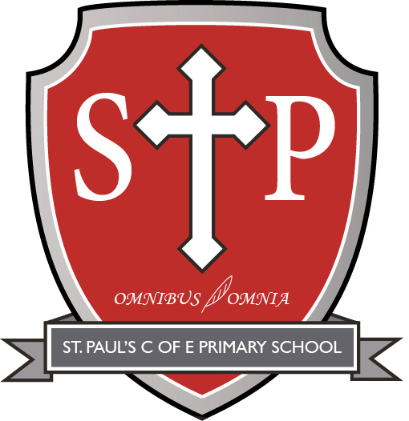

LANGUAGES
POLICY

1. Purpose of the policy
This policy reflects the aims and values of St. Paul’s CE Primary School. It ensures all stakeholders, including staff, governors, parents and pupils, are working towards the same goals.
The purpose of this policy is to:
- Set out a framework for all teaching and non-teaching staff, giving guidance on planning, teaching and assessment
- Demonstrate adherence to the National Curriculum objectives and guidelines
- Provide clear information to parents and carers about what their children will be taught
- Allow the governing board to monitor the curriculum
- Provide Ofsted inspectors with evidence of curriculum planning and implementation

2. Subject vision
Modern Foreign Languages (MFL) is an important part of our school curriculum. As a school, we learn French which is a very well-known language spoken in 29 countries across the world. French is also spoken within our school community making this a crucial aspect of our learning. Learning French allows French speaking children time to learn more and expand their own home spoken language; but it also encourages friendships between other children who are just beginning to learn. French will help build communities and start conversations.

3. Intent: Aims and outcomes
By the time our pupils leave St. Paul’s, they should:
- understand and respond to spoken and written language from a variety of authentic sources
- speak with increasing confidence, fluency and spontaneity, finding ways of communicating what they want to say, including through discussion and asking questions, and continually improving the accuracy of their pronunciation and intonation
- write at varying length, for different purposes and audiences, using the variety of grammatical structures that they have learnt
- discover and develop an appreciation of a range of writing in the language studied.
Key Stage 2
Teaching should focus on enabling pupils to make substantial progress in one language - French. The teaching should provide an appropriate balance of spoken and written language and should lay the foundations for further foreign language teaching at key stage 3. It should enable pupils to understand and communicate ideas, facts and feelings in speech and writing, focused on familiar and routine matters, using their knowledge of phonology, grammatical structures and vocabulary. The focus of study in modern languages will be on practical communication. Pupils should be taught to:
- listen attentively to spoken language and show understanding by joining in and responding
- explore the patterns and sounds of language through songs and rhymes and link the spelling, sound and meaning of words
- engage in conversations; ask and answer questions; express opinions and respond to those of others; seek clarification and help
- speak in sentences, using familiar vocabulary, phrases and basic language structures
- develop accurate pronunciation and intonation so that others understand when they are reading aloud or using familiar words and phrases
- present ideas and information orally to a range of audiences
- read carefully and show understanding of words, phrases and simple writing
- appreciate stories, songs, poems and rhymes in the language
- broaden their vocabulary and develop their ability to understand new words that are introduced into familiar written material, including through using a dictionary
- write phrases from memory, and adapt these to create new sentences, to express ideas clearly
- describe people, places, things and actions orally and in writing
- understand basic grammar appropriate to the language being studied, including: feminine, masculine and neuter forms and the conjugation of high-frequency verbs; key features and patterns of the language; how to apply these, for instance, to build sentences; and how these differ from or are similar to English.

4. Implementation: Teaching and learning
At St. Paul’s, we use a variety of teaching and learning styles in MFL lessons. Our principle aim is to enable pupils to think as linguists. Lesson plans are based around the Language Angels scheme of work with objectives adapted to suit the stage of development for the pupils in each class. The teaching of MFL might involve:
- Whole-class teaching
- Small group discussions
- ICT to enhance their learning
- Role play/drama-based activities
At St. Paul’s, we recognise that in all classes children have a wide range of abilities, and we ensure that we provide suitable learning opportunities for all children by matching the challenge of the task to the ability of the child. We achieve this in a variety of ways:
- We set tasks which are open-ended and can have a variety of responses
- We set tasks which can be adapted for different children either to increasing difficulty or support them
- We group children by ability for some tasks, in mixed ability groups for others and independently for some tasks. Sometimes each type of grouping will have different activities, other times this may just include having additional support offered to them
- We provide resources of different complexity, matched to the ability of the child
- We use adults in the classroom to support the work of individual children or groups of children.
All children regardless of their race, sex, religion or ability will be given equal opportunities to develop their knowledge, skills and understanding of MFL. Care is taken when selecting source material that a range of perspectives and viewpoints are represented; including those of men and women of different racial, national or religious groups. Care is taken that societies are not just represented from the British perspective but also from their own. The importance of the pupil’s own cultural background is recognised as a resource.

5. Curriculum overview
Here at St. Paul’s, pupils will follow a MFL curriculum that gradually develops learning, providing an opening to other cultures. It should foster pupils’ curiosity and deepen their understanding of the world. The teaching should enable pupils to express their ideas and thoughts in another language and to understand and respond to its speakers, both in speech and in writing. It should also provide opportunities for them to communicate for practical purposes, learn new ways of thinking and read great literature in the original language. Language teaching should provide the foundation for learning further languages, equipping pupils to study and work in other countries. Children will know more, remember more and do more. MFL is taught and planned as a discrete subject. We carry out our curriculum planning in three phases: whole-school overview, schemes of work and short-term plans.
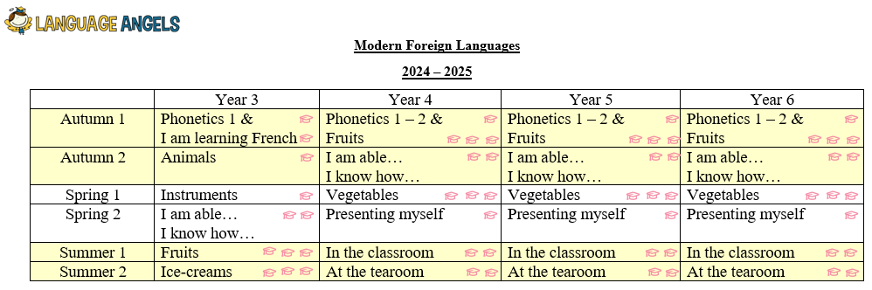
Our key stage 2 overview maps out the MFL topics studied during each year group:
As St. Paul’s have only been using Language Angels to support our MFL learning for 1 year, we have adapted the whole school overview for this year to ensure there is a suitable progression for our pupils based on their starting points. Our schemes of work outline the knowledge nuggets taught in each topic and are based on the objectives found in the National Curriculum (https://assets.publishing.service.gov.uk/media/5a7b9246e5274a7318b8f889/PRIMARY_national_curriculum_-_Languages.pdf ). All children have access to knowledge organisers for reference and consolidation of skill information and vocabulary. Our knowledge organisers can be found on the school website: https://www.stpaulsce.co.uk/year-group-curriculum-overviews/
6. Cross-curricular links
MFL shares links with the following subjects:
- English: development of literacy skills through reading, writing, speaking and listening and learning new and specific French language
- Maths: knowledge of number and time
- ICT: use of the internet for research and to find, select and analyse information. Video clips are also used to animate French conversations and allows children to immerse themselves in French culture which would be impossible to do directly in the classroom otherwise.

7. Impact: Assessment and recording
Assessment
St. Paul’s uses assessment to enable staff to understand what pupils have learnt before, what they need to learn now and what they will learn next.
Formative assessment
Formative MFL assessment is ongoing and will be used to inform teachers in relation to their planning, lesson activities and differentiation. During lessons, teachers will make informal judgements continuously. At the end of the lesson, the teacher assesses the pupil’s work and will make a judgement to inform future planning. Feedback (either written or verbal) is given to each child to help guide their progress.
Summative assessment
Summative assessment is completed at the end of a language unit, based on the skills and knowledge nuggets found on the schemes of work. This will be completed using teacher assessment. Teachers will use assessment checkpoints throughout the unit and the assessment criteria on the schemes of work to make their judgements.
Further assessment information can be found in the school’s assessment policy.
Marking
Children receive regular verbal and written feedback and marking follows the school’s marking policy.
Further marking information can be found in the school’s marking policy.
Recording
In MFL, pupils will record their learning in the following ways:
- French books
- Seesaw
This may take the form of photographs, pictures, notes or written work, and may be worksheet-based or fully independent.

8. Enrichment Curriculum & Resources
Subscriptions
Language Angels
Events
European Languages Day

9. Roles and responsibilities
Headteacher
The headteacher at our school will:
- Support the subject leader but also hold them to account for the effectiveness of the subject
- Support staff through the provision of training and resources
- Monitor the planning and delivery of the subject
- Ensure the requirements of the National Curriculum are met
- Ensure this policy is reviewed according to the timescales set out
Subject leader
The subject leaders at our school will:
- Prepare and review subject policy and curriculum plans
- Promote the study of the subject throughout the school
- Monitor the teaching and assessment of the subject (using subject leader journal)
- Attend appropriate CPD
- Stay informed regarding developments in the study and teaching of the subject
- Evaluate resources
- Provide support, training and CPD to staff on the subject curriculum and its delivery, and keep them informed about subject developments nationally
- Assess the impact of the subject curriculum on pupils’ learning and development
- Make presentations to governors on the subject and how it is being taught
- Provide the Headteacher with a summary report in which the strengths and weaknesses of science are evaluated and indicated areas for further development
Classroom teacher
Classroom teachers at our school will:
- Plan, teach and assess the subject according to the principles laid out in this policy
- Report to the subject leader
- Maintain subject knowledge and appropriate CPD
Parents
The parent community at our school will:
- Make sure their children are prepared for learning
- Support their children to complete project book activities

10. Inclusion
At St. Paul’s, teachers set high expectations for all pupils in MFL, whatever their ability and individual needs. Languages forms part of the school curriculum policy to provide a broad and balanced education to all children and we acknowledge that learners with additional needs are likely to experience difficulties within their learning which may act as barriers. Through our MFL teaching, we provide learning opportunities that enable all pupils to make good progress by adapting the teaching of languages to suit the needs of all pupils. We strive hard to meet the needs and will use appropriate assessment to set ambitious targets and plan challenging work for all groups, including:
- More-able pupils
- Pupils with low prior attainment
- Pupils from disadvantaged backgrounds
- Pupils with special educational needs (SEN)
- Pupils with English as an additional language (EAL)
Teachers carefully consider these adaptations as shown below:
Cognition and Learning
Barriers | Provision
Recall of vocabulary in English to be able to translate to French.  Different structure of sentences may be difficult for children whose sentence level knowledge is poor in English | - Use of knowledge organisers, pictorial, real objects and representations with French and English versions.  - Embed vocabulary through chats, songs rhymes and other ways that will support recall.  - Use visuals to represent masculine and feminine verbs in French.  - Avoid the need for copying lots of information from the board.  - Use sentence strips, coloured sentences etc to enable physical moving around of words.  - Recording using alternative methods.  - Use of talking tin so sentences can be played back to support appropriate sentence structure.
Communication and Interaction
Barriers | Provision
Poor language levels in child’s first language.  Slow language processing skills.  Anxiety speaking aloud in either language. | - Ensure that children know the language/vocab being taught in English prior to the introduction of a second language.  - Pre-teach and key vocab to ensure a secure understanding.  - Be aware that children with slow language processing skills will need even more time to verbalise in another language.  - Give additional thinking time  - Oral rehearsal time with a peer or trusted adult before asked to say it aloud.  - Be aware receptive language skills may be better than spoken language skills. Do not assume that because they cannot say it that they do not understand – offer alternative ways to show knowledge (pictures etc.)  - Model mistakes with language and ask children to identify. Foster learning in a culture of having a go/growth mind-set.
Physical and Sensory
Barriers | Provision
Hearing language clearly if hearing impairment.  Sensory overload during more conversational/interactive lessons. | - Ensure child is sitting near the front of the class and can see you as well as hear you.  - Support language with gesture, signing and visuals to aid understanding.  - Think about classroom acoustics and background noise.  - Be aware of individual needs – children who may be uncomfortable in loud environments etc.  - Practical role play may cause challenges for some children – shaking hands and saying Bonjour if child does not like touch etc.
Social, Emotional and Mental Health
Barriers | Provision
Anxiety over making mistakes/looking silly.  Difficulty regulating behaviour in less structured lessons. | - Foster an environment in which mistakes become learning points. Encourage a ‘have a go’ ethos.  - Allow child to orally rehearse sentences to themselves or using a talking tin.  - Visual representations of feeling overwhelmed.  - Time out/breaks from the activity to calm down/reset.  - Use of fidget aids, wobble cushions to aid concentration.  - Opportunities to develop social skills including being taught these discretely to support engagement in group work and collaborative learning.  - Use of PSHE to discuss healthy relationships, promote wellbeing and explore emotive topics within learning.
Further information can be found in our statement of equality information and objectives, and in our SEN policy and information report.

11. Health and Safety
Children at St. Paul’s are taught how to use equipment/resources safely and with respect.
Risk assessments and school health and safety procedures should be followed when out of
school on trips or when there are visitors in school.

12. Links to other policies
This subject policy links to the following policies and procedures:
- Curriculum policy
- Assessment policy
- Marking policy
- SEN policy

13. Monitoring and review
This policy will be reviewed by staff and governors annually.

